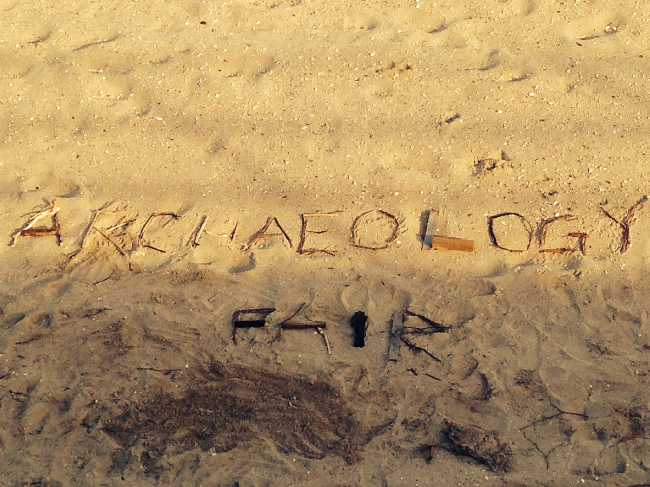

**GET YOUR HANDS DIRTY.**

**DIG. DISCOVER. BUILD. PRESERVE.**

**WHAT: Staten Island Archaeology Fair**

**WHEN: Sunday, April 27th, 2014 from 11am-3pm**

**WHERE: Wagner College Spiro Sports Center**

The Staten Island Archaeological Society presents a Sunday filled with excavations, explorations, and education! Here's what you need to know:

* Activities for all ages, including a scavenger hunt, an archaeology dig, and so many more!
* Free to attend! Free and convenient parking!
* Sponsored by the Staten Island Archaeology Society (**siarchaeology.org**)

Contact Meredith Ketchmark at [**meredith.ketchmark@wagner.edu**](mailto:meredith.ketchmark@wagner.edu) **and**

Connect with us to learn more:

 [www.facebook.com/siarchfair2014](http://www.facebook.com/siarchfair2014)  @SIArchFair2014  @SIArchFair2014